Using Tableau, we will extract insights from the sales data of more than 16327 global video game sales.

**Video Games Sales Data Analysis & Visualization**

**Functional Objective** — To develop a filtering system and an interactive sales dashboard with several graph types.

**Report Visuals:**

a. Sales by Years and Genre

b. Top 10 Platforms by Sales

c. Top 10 Names by Sales

c. Total Sales per Genres

d. Top 10 Publishers by Sales

e. Score Cards

f. Reports should be filtered based on Zone sales, all individual charts and can view individual genre details.

**Using the steps below to begin with data visualization:**

Getting the data - You can download dataset from Kaggle, link below -

https://www.kaggle.com/datasets/gregorut/videogamesales

**In the above dataset, the fields include :**

Rank - Ranking of overall sales

Name - The games name

Platform - Platform of the games release (i.e. PC,PS4, etc.)

Year - Year of the game's release

Genre - Genre of the game

Publisher - Publisher of the game

NA_Sales - Sales in North America (in millions)

EU_Sales - Sales in Europe (in millions)

JP_Sales - Sales in Japan (in millions)

Other_Sales - Sales in the rest of the world (in millions)

Global_Sales - Total worldwide sales.

**Connecting the data to Tableau**

There are many options for connecting data, including text, csv, and excel. Also, you can connect using servers and real-time data.

In this case, I'll use Microsoft Excel to connect the data. You must start on Sheet 1 since there is only one sheet.

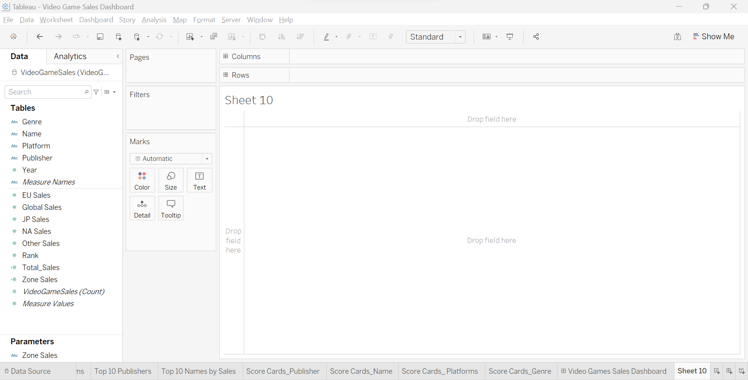

The left-hand side of the figure shows all of the columns from the dataset; the upper portion is made up of dimensions, or text values, while the lower part is made up of measures, or columns with numerical values.

**Creating Parameters and Measures**

Our first parameter will be for Zone sales, and it will be a single-value list filter that allows us to choose or view sales for that Zone alone. NA, JP, EU, Other, and Global sales are included in the zones. The entire zone's sales can also be seen in a graph with this tool.

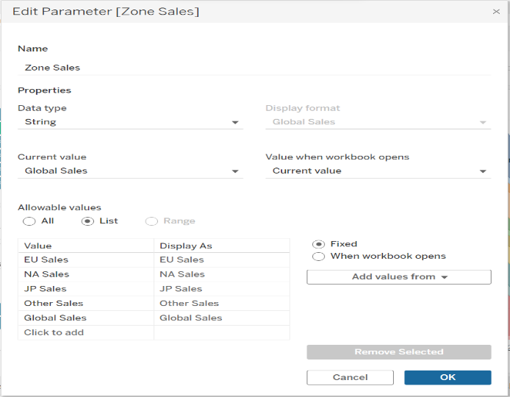You must click on the right-hand triangle shape in the search tab and choose "Create Parameter" from the options in order to create a parameter.

Set the data type to "String," add "Zone Sales," and choose List from the list of permitted values. Put all zones in the value column and the same in Display as after that. Press OK. We will now utilize the CASE function to build a calculated field for Zones. Ex: CASE [Zone Sales] is what we use for European sales. When EU Sales OCCUR THEN #EU Sales from measures, we'll act similarly for all zones. Then click OK and Apply.

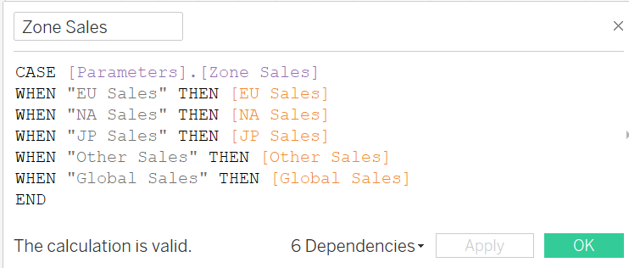

**Creating Visuals**

1. **Sales by Years and Genre**

You can begin visualizing data. In this, we'll drag the Year and drop it into the Sheet 1 columns area. then pick the Zone Sales that we generated using the calculation and parameter fields in the row section.

An area chart will be presented. Then, we'll choose Display parameter under Parameter so that it acts as a filter for all Zones on the graph's right side. Drag the Genre from columns to colours in the marks section if you want to see sales by genre. Genres will be divided on the graph as a result. We must now drag the Year measure into the Filter area before choosing Display filter from the context menu when right-clicking. For genre, we may apply the same strategy.

We can experiment with the filters we've made and construct an interactive graphic or graph to observe the sales from a specific zone or genre.

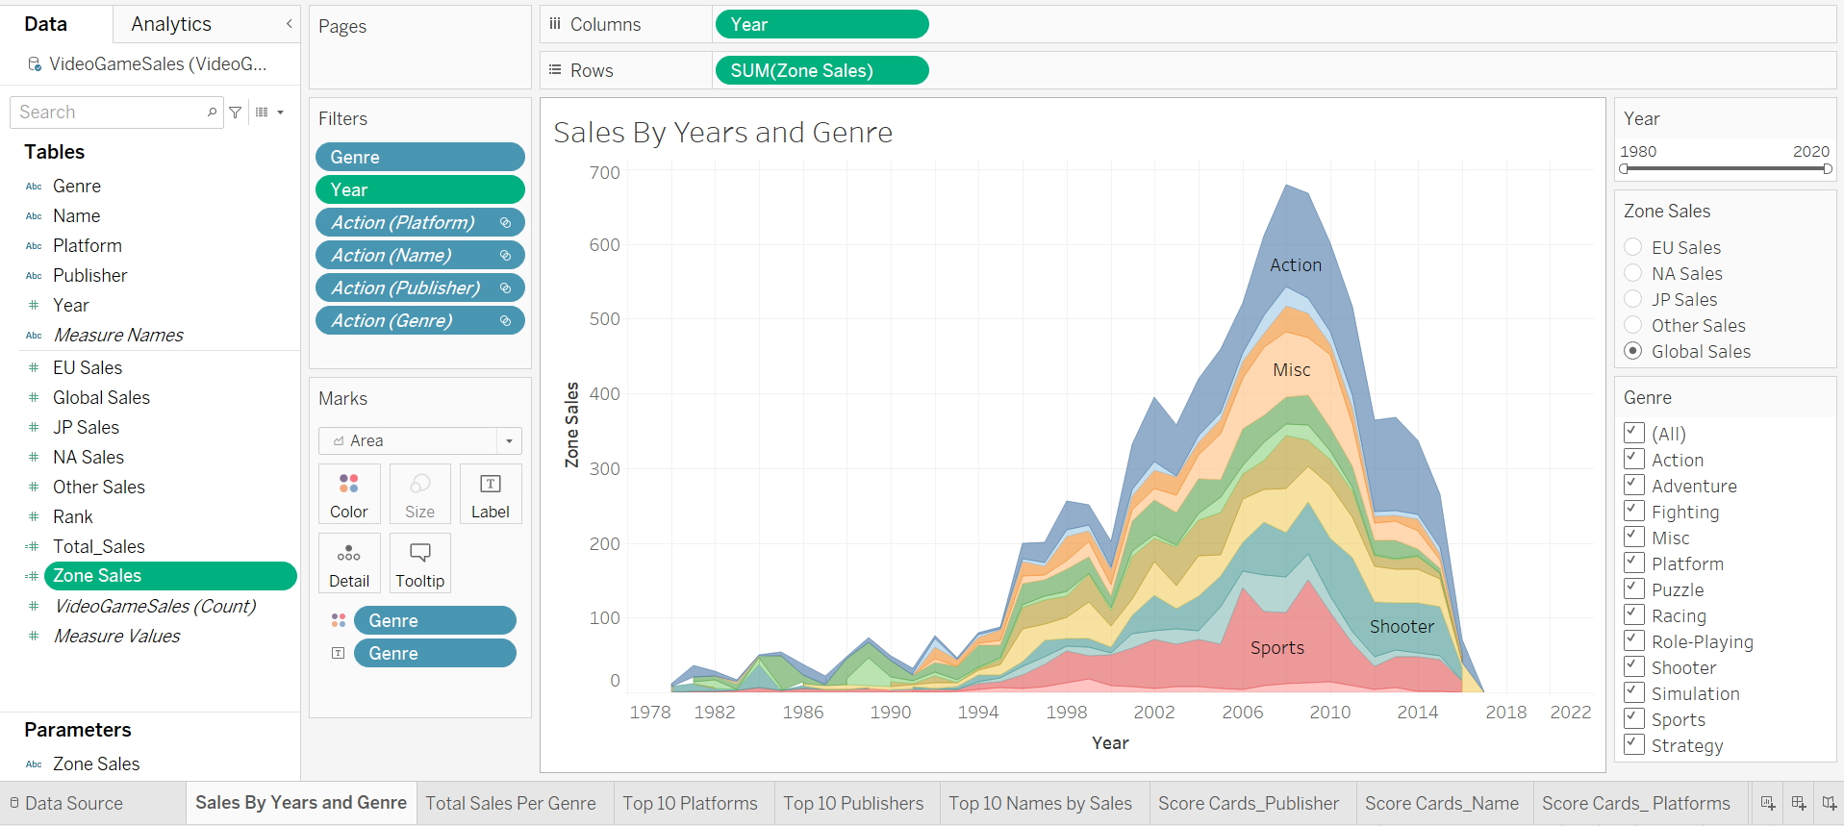

**Observations:**Among all genres, we could determine that the Action genre had the largest sales. According to sales, strategy is the least effective. The rest are all making typical sales throughout all zones. North American sales are the highest in zones, followed by those from Europe, while those from Japan and other countries are lower. If we look at sales by year, we can see that after 1995 and up until 2008–09, the graph moved up, but it started to go down after 2010.

1. **Total Sales per Genre**

To do this, we will use a bar chart. When comparing various categories, a bar graph might be utilized. Selecting a bar chart, we must place Genre in the column, Total Zone Sales in the row. Tableau frequently suggests the graph per measurements. The **Show me** option allows us to alter the graph type at any time. We will drag Zone Sales on **Label** in the Marks area to add labels to the graph.

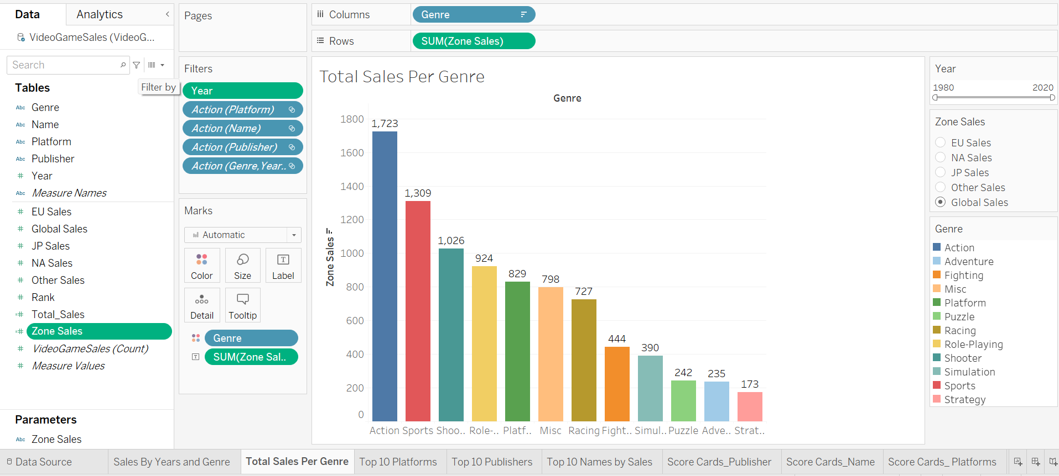

**Observations:** We can observe that the Action genre has seen the greatest global sales success, with Puzzles, Adventures, and Strategy coming in last. Comparing the sales of Sports and Shooter to those of Race, Combat, and other genres.

1. **Top 10 Platforms by Sales**

Bubble charts will be used to identify the top 10 platforms. For this we need Platform and Zone Sales and select the Bubble chart. We'll use the filter area, choose Top and By Field, then add 10 by Zone Sales and Sum to get the top 10 platforms.

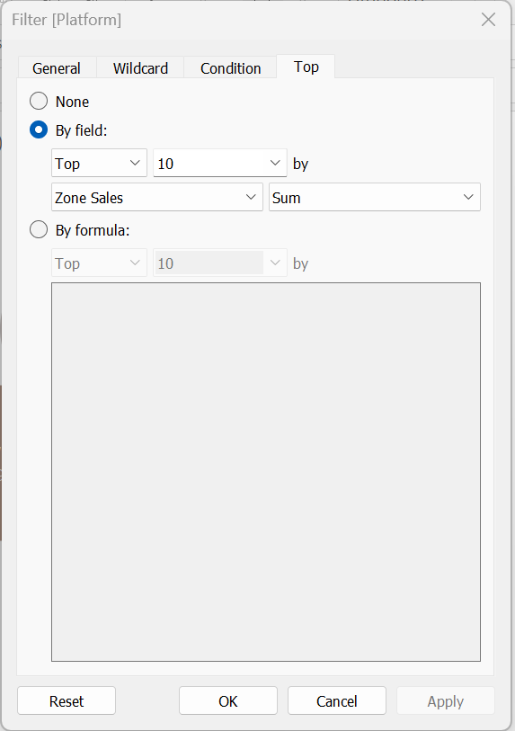

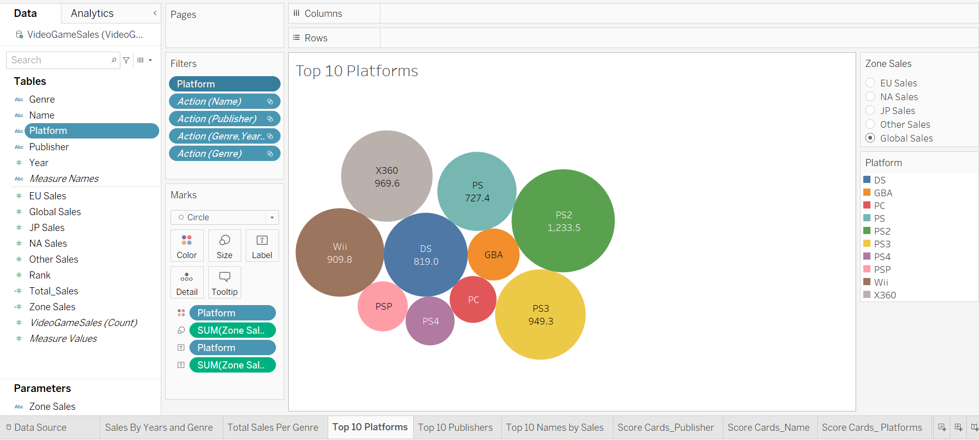

**Observations:** The PS2 is the platform with the highest sales, followed by the X360, PS3, Wii, and DS. These were the top 5 platforms with significant sales.

1. **Top 10 Names by Sales**

For this report, we'll be using a horizontal bar charts. Horizontal bar charts are also easily sorted to present highs and lows. We need the names and the total zone sales in order to build the horizontal bar charts. Choose the horizontal bar charts, then filter the top 10 results using the same steps as with the bubble chart above.

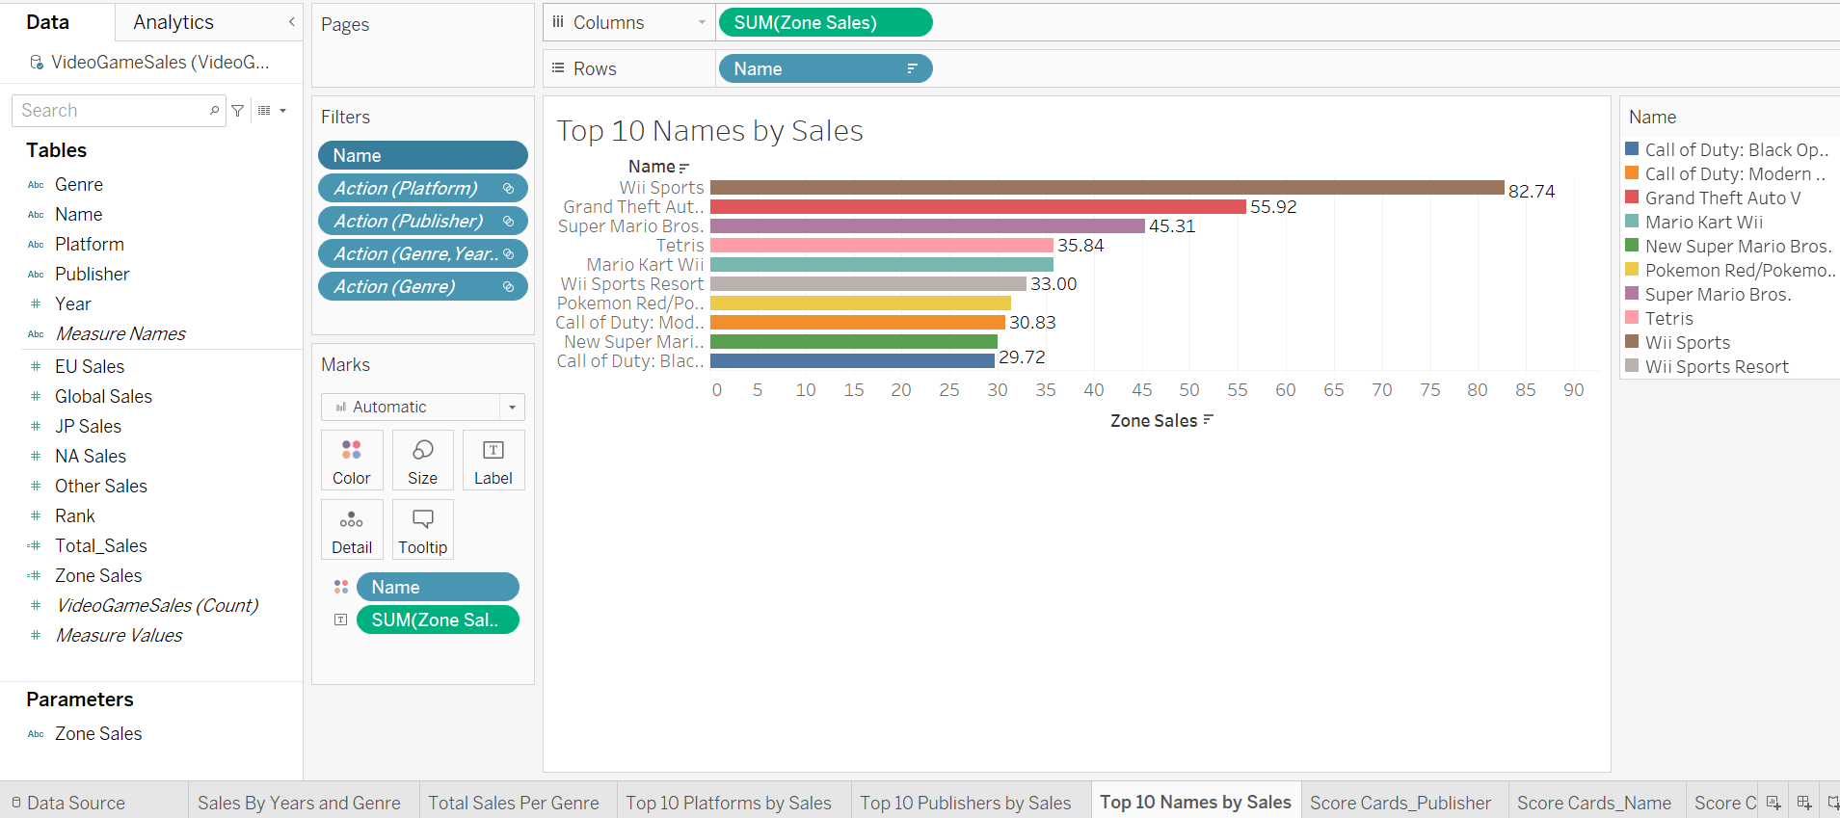

1. **Top 10 Publishers by Sales**

For this report, we'll be using a heat map. A heatmap shows the value of a key variable across two axes as a grid of coloured squares. We need the publisher and the total zone sales in order to build the heat map. Choose the heat map, then filter the top 10 results using the same steps as with the horizontal bar chart above.

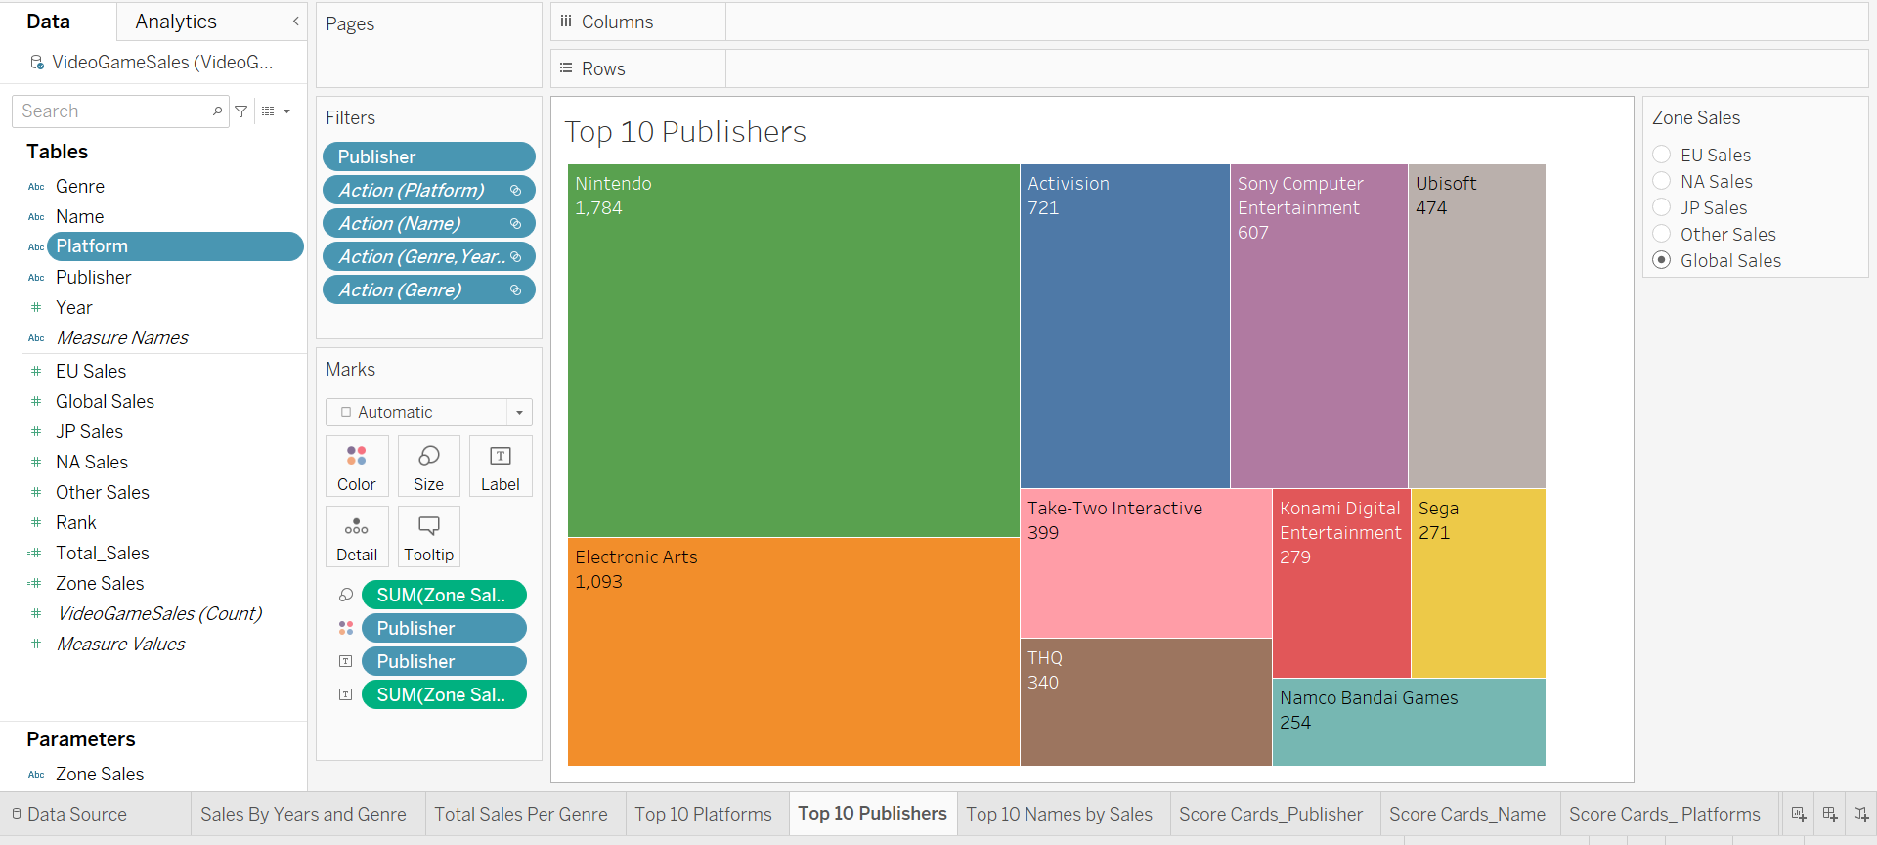

**Observations:** We can see which grids with the darkest colours had the biggest sales. In terms of publishers, Nintendo is in the lead. Activision and Electronic Arts came in second and third place, respectively. While some are simply ordinary sellers.

1. **Score Cards**

We can find Total Games, publishers, platforms and genres by Adding particular dimension into Text in Marks section. This will give count of each category. Then we can merge them in Dashboard.

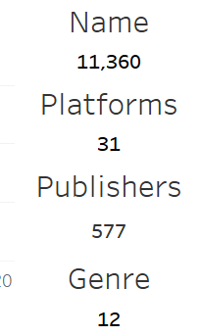

**Dashboard Creation**

The Dashboard option is located beside sheets, and we must select it in order to construct a dashboard. To create a clean and readable dashboard, select the desired dashboard size, drag and drop the necessary sheets there, and organize them logically. For Dashboard, provide a name or title.

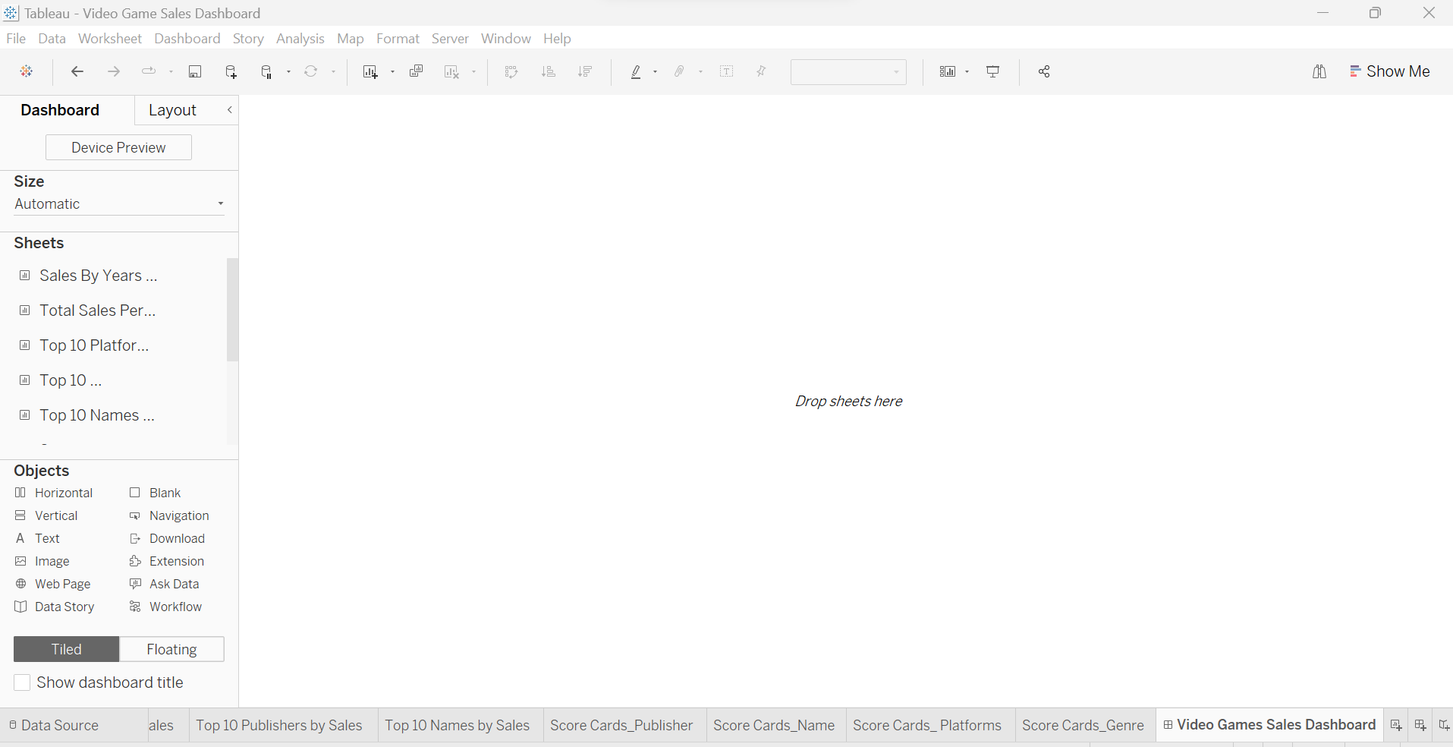

**Final Report**

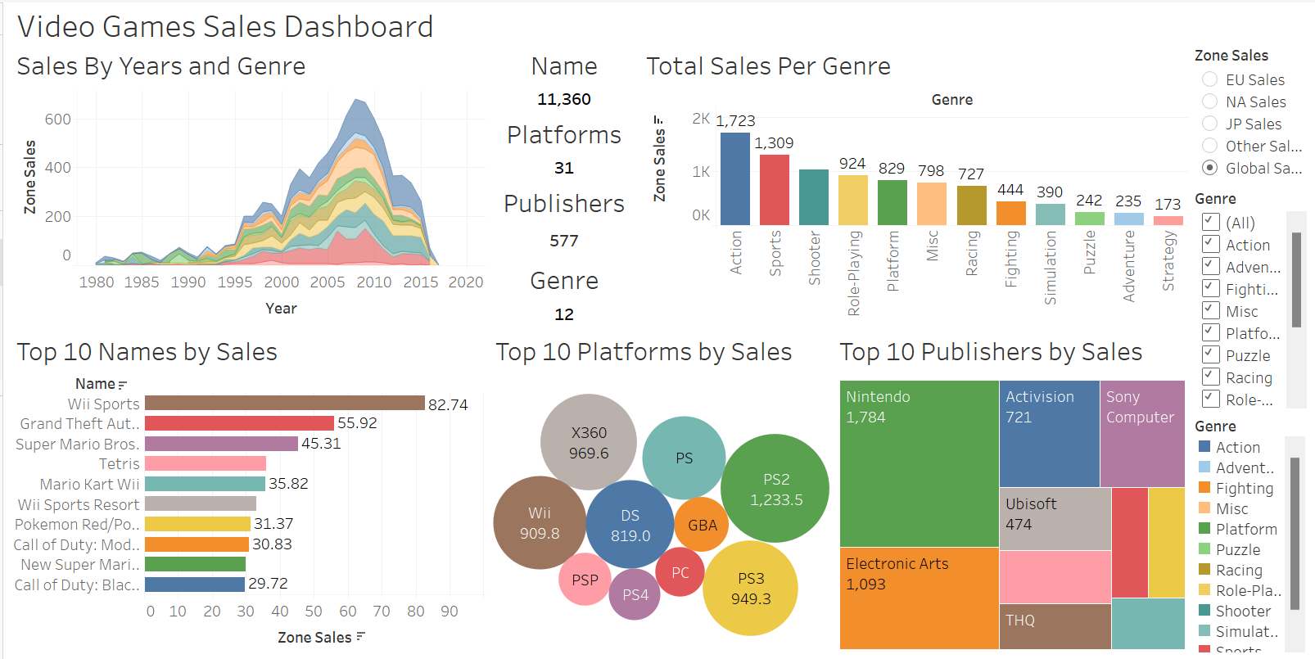

**Publish and Share**

By registering with tableau public, you can publish the dashboard and save it for later use. You can register with your email address. The dashboard can be shared via a link.

**Conclusions and Outcomes**

1. Action Genre has created high sales amongst rest 12 genres.
2. Nintendo is the top contributor in all publishers selling highest number of games.
3. Wii Sports is ranking number 1 amongst video games.
4. Strategy and Adventure are least selling genres.
5. Highest games were sold in year 2008–09.
6. Northern American sales are highest and least sales were in Japan.
7. Followed by Japan, Other countries sales are also less as compared to North America and European sales.
8. There are 16327 games and 11360 distinct games with 577 publishers and 31 platforms across the globe having 12 genres.